Name: Mustafa Senih Topsakal

Date: 10/31/2021

Do:

Exercises 6.2 (Q1/Q2/Q8)

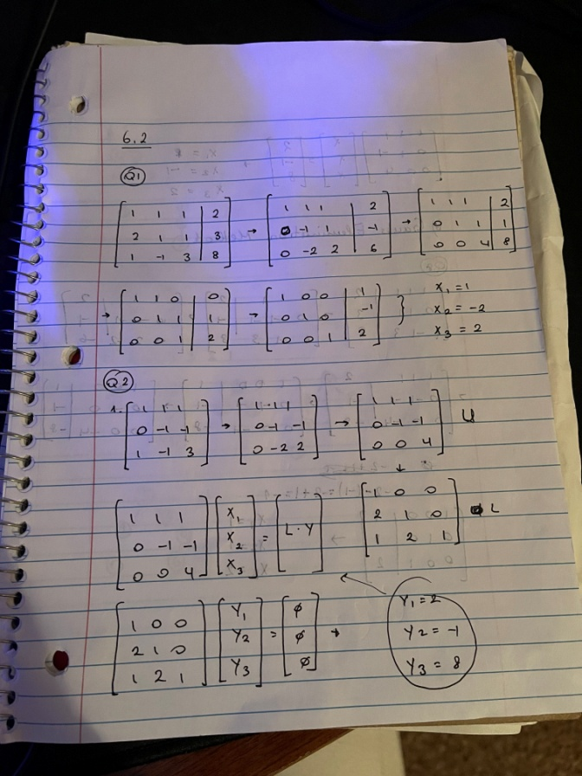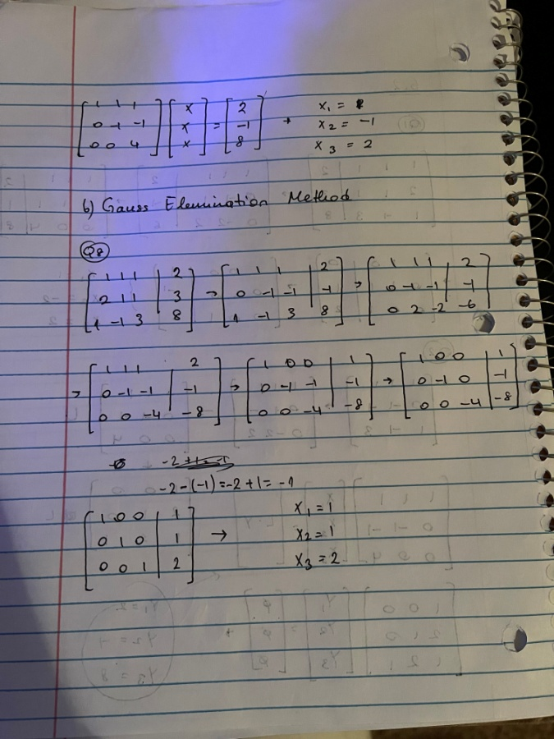

Exercises 6.3 (Q4)

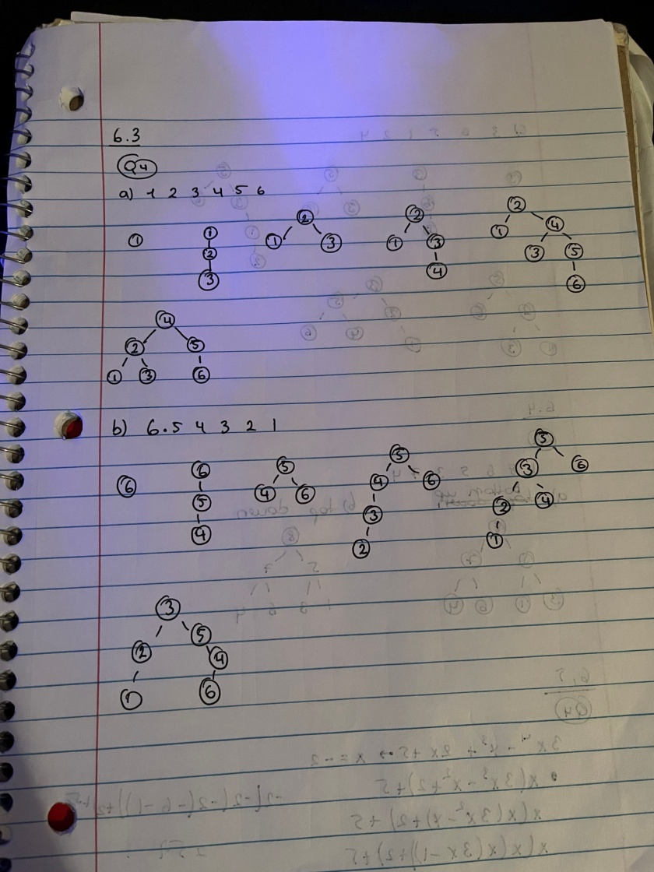

Exercises 6.4 (Q1)

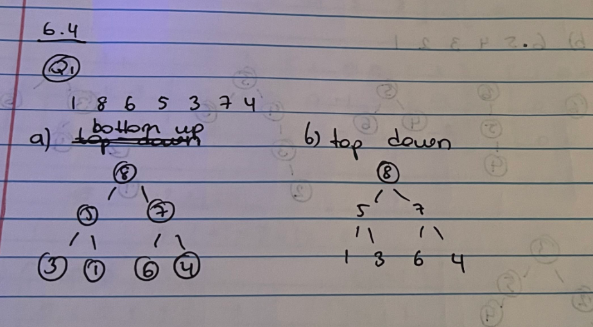

Exercises 6.5 (Q4)

